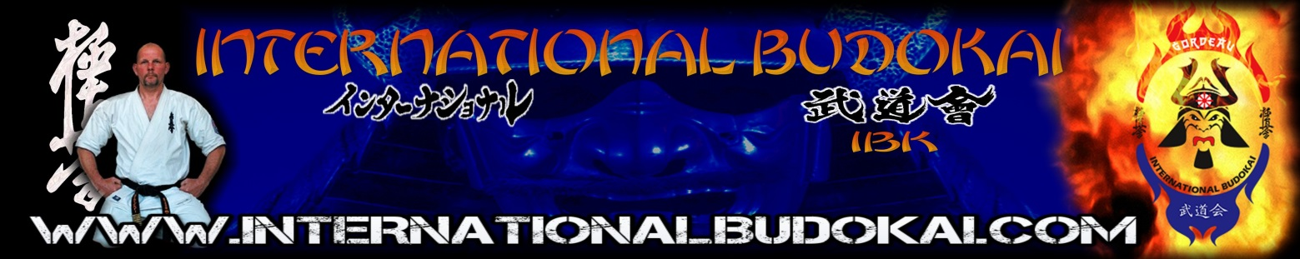
IBK INTERNATIONAL INFORMATION / RULES DOJO OWNERS AND REPRESENTATIVES
UPDATE JULY 2019

- INTERNATIONAL BUDOKAI BOARD MEMBERS ARE: KANCHO GERARD GORDEAU, SENSEI ROBERT PEPELS AND SEMPAI CEM SENOL
- THE ONLY OFFICIAL CONTACT OF THE IBK FOR ALL INFO AND QUESTIONS = INTERNATIONALBUDOKAI@GMAIL.COM USE THIS ADRESS FOR EVERYTHING: NEWS, ACTIVITIES, SEMINARS, MEMBERSHIPS AND ALL OTHER IBK MATTERS, WE WILL NOT ANSWER ON OTHER EMAIL ADRESSES
- INTERNATIONAL DOJO’S SHOULD HAVE A NATIONAL IBK CONTACT POINT AND CONTACT PERSON (OR MULTIPLE), SEND THIS CONTACT PERSONS EMAIL TO INTERNATIONALBUDOKAI@GMAIL.COM
- PAY THE IBK ANNUAL MEMBERSHIP FEE ON TIME
- REGISTER ALL IBK DOJO’S IN YOUR COUNTRY
- YOU HAVE TO USE THE IBK OFFICIAL LOGO’S ON YOUR PAGES, FORMS, POSTERS, UNIFORMS AND WEBSITES
- SEND US INFO AND NEWS ON A REGULAR BASE SO WE CAN NOW WHAT IS GOING ON WITH YOURE IBK DOJO OR COUNTRY
- THE ONLY OFFICIAL BODY FOR THE IBK = WWW.INTERNATIONALBUDOKAI.COM SEE THIS WEBSITE FOR NEWS, ACTIVITIES AND SEMINARS, CAMPS ETC. DO YOU WANT YOURE NEWS AND INFO ON THE SITE? THEN EMAIL US (FACEBOOK IS NOT AN OFFICIAL BODY)
- REMEMBER NEXT YEAR MARCH 15 WE HAVE OUR 30TH OPEN EUROPEAN KYOKUSHIN CHAMPIONSHIP IN THE HAGUE NETHERLANDS, SEND YOUR TEAMS AND BOOK IN TIME (VISA)
- PROMOTE THE IBK IN YOUR DOJO, COUNTRY ETC ALSO USE THE LOGO, TRY TO FIND MEMBERS AND DOJO’S TO JOIN US, REGIONAL, NATIONAL AND INTERNATIONAL
- THE HIGHEST DEGREE A PERSON CAN OBTAIN WITHIN IBK = 6 DAN
- IN DECEMBER 2019 IBK ORGANIZES A TRIP TO JAPAN, ALL MEMBERS ARE WELCOME TO JOIN, CONTACT SEMPAI SENOL FOR THIS, EMAIL HIM AT INFO@DOJO-OSAKA.NL BE IN TIME TO JOIN
- ALL REPRESENTATIVES, DO NOT PLAN IBK RELATED EVENTS AT THE SAME DATE / TIME, CONTACT EACH OTHER
- BE ON TIME IN THE SUMMERCAMP NOT 1 DAY LATER
- FILL IN THE IBK PASPORTS WITH THE COMPLETE INFO
- FOR YUDANSHA TESTING AT THE SUMMERCAMP, SEND IN THE FORM BEFORE 1ST JULY TO HANSHI NICO GORDEAU (C.C TO IBK EMAIL)
- THE FEE FOR ALL YUDANSHA TESTING IS 150 EURO FOR ALL BLACKBELTS
- EVENTS HUNGARY 14/09/2019 100-MAN KUMITE, 26/10/2019 HINOMOTO CUP, 15-02-2020 HUNGARIAN CHAMPIONSHIP
- SUMMERCAMP FROM 12 YEARS OF AGE

OSU

KANCHO G.GORDEAU
WWW.INTERNATIONALBUDOKAI.COM

